# Exercises: Strings, Dictionaries, Lambda and LINQ

Problems for exercises and homework for the [“Programming Fundamentals” course @ SoftUni](https://softuni.bg/courses/programming-fundamentals).

You can check your solutions here: <https://judge.softuni.bg/Contests/174/Strings-Dictionaries-Lambda-and-LINQ-Lab>

## Print String Letters

### Read a string and print its letters as in the examples below:

### Examples

|  |  |
| --- | --- |
| **Input** | **Output** |
| SoftUni | str[0] -> 'S'  str[1] -> 'o'  str[2] -> 'f'  str[3] -> 't'  str[4] -> 'U'  str[5] -> 'n'  str[6] -> 'i' |

## Count Letters in String

### Read a string and count how many times each character occurs. Print all chars (case insensitive) alphabetically with their counts

### Examples

|  |  |  |  |  |  |  |  |
| --- | --- | --- | --- | --- | --- | --- | --- |
| **Input** | **Output** |  | **Input** | **Output** |  | **Input** | **Output** |
| Alabala | a -> 4  b -> 1  l -> 2 |  | ooooo, kef | -> 1  , -> 1  e -> 1  f -> 1  k -> 1  o -> 5 |  | C# Basics | -> 1  # -> 1  a -> 1  b -> 1  c -> 2  i -> 1  s -> 2 |

## Print a Receipt

Read a **sequence of numbers** and **print a receipt** of width 24 chars:

### Examples

|  |  |  |  |  |
| --- | --- | --- | --- | --- |
| **Input** | **Output** |  | **Input** | **Output** |
| 12.5 7 0.50234 | **/----------------------\**  **| 12.50 |**  **| 7.00 |**  **| 0.50 |**  **|----------------------|**  **| Total: 20.00 |**  **\----------------------/** |  | 460 000230 450.6666666 | **/----------------------\**  **| 460.00 |**  **| 230.00 |**  **| 450.67 |**  **|----------------------|**  **| Total: 1140.67 |**  **\----------------------/** |

## Occurrences in String

Read a **text** and a **word** and count **how many times the word occurs** in the text **as substring.**

### Examples

|  |  |  |  |  |  |  |  |
| --- | --- | --- | --- | --- | --- | --- | --- |
| **Input** | **Output** |  | **Input** | **Output** |  | **Input** | **Output** |
| Alabala  la | 2 |  | aaaabaaa  aa | 5 |  | Hello, hello  he | 2 |

### Hint

* Use **text.IndexOf(word, offset)** in a loop

## Forbidden Substrings

### Read a text and several forbidden words. Replace all forbidden words with stars (e.g. beer -> ****). Use "substring" matching (match part of word), case-sensitive:

### Examples

|  |  |
| --- | --- |
| **Input** | **Output** |
| Learn how to earn money or read the HOWto e-learning  beer how programming PHP MySQL earn bitcoins  earn | **L**** *** to **** money or read the HOWto e-l****ing** |

## Count Real Numbers

### Read a list of real numbers and print them in ascending order along with their number of occurrences

### Examples

|  |  |  |  |  |  |  |  |
| --- | --- | --- | --- | --- | --- | --- | --- |
| **Input** | **Output** |  | **Input** | **Output** |  | **Input** | **Output** |
| 8 2.5 2.5 8 2.5 | 2.5 -> 3 times  8 -> 2 times |  | 1.5 5 1.5 3 | 1.5 -> 2 times  3 -> 1 times  5 -> 1 times |  | -2 0.33 0.33 2 | -2 -> 1 times  0.33 -> 2 times  2 -> 1 times |

## Odd Occurrences

### Write a program that extracts from a given sequence of words all elements that present in it odd number of times (case-insensitive)

### Words are given in a single line, space separated

### Print the result elements in lowercase, in their order of appearance

### Examples

|  |  |
| --- | --- |
| **Input** | **Output** |
| Java C# PHP PHP JAVA C java | java, c#, c |
| 3 5 5 hi pi HO Hi 5 ho 3 hi pi | 5, hi |
| a a A SQL xx a xx a A a XX c | a, SQL, xx, c |

## Largest 3 Numbers

Read a **list of real numbers** and **print largest 3 of them**

### Examples

|  |  |
| --- | --- |
| **Input** | **Output** |
| 10 30 15 20 50 5 | 50 30 20 |
| 20 30 | 30 20 |

## Short Words Sorted

### Read a text, extract its words, find all short words (less than 5 characters) and print them alphabetically, in lower case

### Use the following separators: . , : ; ( ) [ ] " ' ! ? (space)

### Use case-insensitive matching; remove duplicated words

### Examples

|  |  |
| --- | --- |
| **Input** | **Output** |
| In SoftUni you can study Java, C#, PHP and JavaScript. JAVA and c# developers graduate in 2-3 years. Go in! | 2-3, and, c#, can, go, in, java, php, you |

## Fold and Sum

Read an array of **4*k integers**, **fold** it like shown below, and print the sum of the upper and lower rows (**2*k integers**):

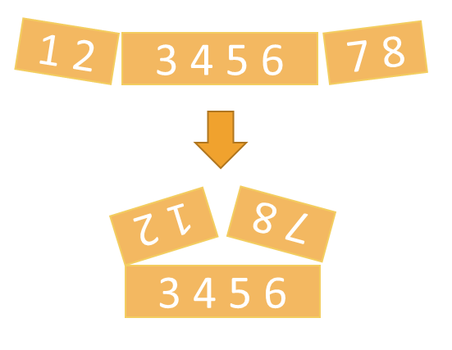



### Examples

|  |  |
| --- | --- |
| **Input** | **Output** |
| 5 2 3 6 | 7 9 |
| 1 2 3 4 5 6 7 8 | 5 5 13 13 |
| 4 3 -1 2 5 0 1 9 8 6 7 -2 | 1 8 4 -1 16 14 |